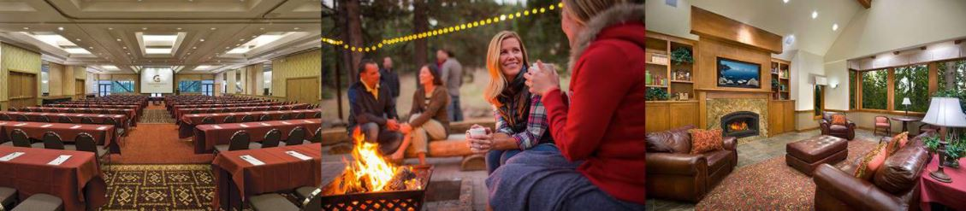
Rotary District 5220 Conference-2020-2021 District Governor Sherry Cotta

Granlibakken Tahoe

September 10-12, 2021
Name: _ Rotary Club: Spouse/Guest Name: Full Conference Registration includes Saturday Night, does not include lodging:
DATE PAID | FEE/Per Person | Number | Total Fee
EARLY BIRD By May 14, 2021 | $325.00
May 15 – June 14, 2021 | $375.00
On or After June 15, 2021 | $425.00
Saturday Night (Sept 11, 2021) ONLY: | $85.00
TOTAL
Checks Payable to Rotary District 5220 – Mail to:
Diana Barden, District Admin Secretary, P.O. Box 1208, Madera CA 93639 REFUND/CANCELLATION POLICY: 50% Refund 6/1/21 through 7/31/21
No Refunds after July 31, 2021
To Register online on DaCdb Calendar with Credit Card click here:
https://Registrations.DACdb.com/Register/ezLink.cfm?EventID=77527793

Special Meal Requests:

# Vegetarian
# Gluten Free
# Other |  | PLEASE SPECIFY:
FOR HOTEL ROOM RESERVATIONS USE GROUP CODE: DIST5220
Below is your reservation link to book your online hotel reservations.
https://granlibakken.com/conferences/

HOTEL INFORMATION:

Guests unable to use our online reservation system can make their reservation by calling (800) 543-3221, identify they are with Rotary District 5220, or use the group code DIST5220 to receive the group rate.

- Reservations can be booked online at https://granlibakken.com/conferences/
- If booking online, and you are prompted that reservations are sold out, please call the reservation line for assistance. There are many reasons that you may receive this message.

If you would like to enjoy the area and extend your stay beyond the dates of the conference, select the number of additional days from the menu and a representative from Granlibakken will contact you to provide pricing and availability information.

- A $100 per person deposit is due at the time of booking.

- Full prepayment is due by 8/24/2021. Please remit payment to: Granlibakken Conference Center, P.O. Box 6329, Tahoe City, CA 96145, or call (800) 543-3221.

- Reservations are due by 8/4/2021 and any reservations received after this date are on a space available basis.

- CANCELLATION at any time is subject to a $0.00 handling fee. Reservations canceled after 8/4/2021 are charged $0.00 per person.

- No shows are charged 2 nights at the package rate. Participants who check-in a day late or check out a day early are charged the full package rate unless the alternate arrival/departure dates are confirmed 72 hours in advance.

- Lodging room check-in time is 4:00 PM and the check-out time is 11:00 AM

